**Azure Service Bus**

Microsoft Azure Service Bus is a fully managed enterprise integration message broker. Service Bus can decouple applications and services. Service Bus offers a reliable and secure platform for asynchronous transfer of data and state.

Data is transferred between different applications and services using *messages*. A message is in binary format and can contain JSON, XML, or just text

#### Steps creating service bus service in Azure portal

1. Sign in to the Azure portal
2. In the left navigation pane of the portal, select **+ Create a resource**, select **Integration**, and then select **Service Bus**.

#### 

#### In the **Create namespace** dialog, do the following steps:

#### Enter a **name for the namespace**. The system immediately checks to see if the name is available

#### Select the pricing tier (Basic, Standard, or Premium) for the namespace.

#### For **Subscription**, choose an Azure subscription in which to create the namespace.

#### For Resource group, choose an existing resource group in which the namespace will live, or create a new one.

#### For Location, choose the region in which your namespace should be hosted.

#### Select Create. The system now creates your namespace and enables it

#### 

1. On the **Resource group** page for your resource group, select your **service bus namespace.**

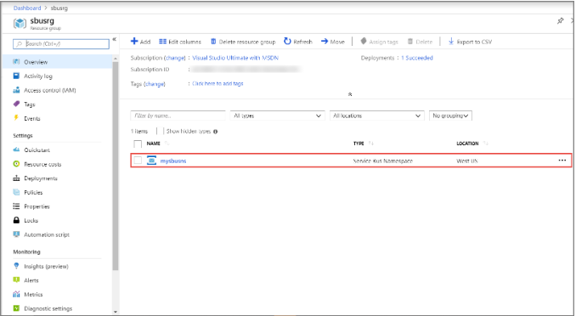

1. You see the home page for your service bus namespace.

#### 

#### In Home page of namespace, click **Shared access policies**.

#### In the **Shared access policies** screen, click **RootManageSharedAccessKey.**

#### 

#### In the **Policy: RootManageSharedAccessKey** window, click the copy button next to **Primary Connection String**, to copy the connection string to your clipboard for later use

#### 

## **Create a topic using the Azure portal**

1. On the Service Bus Namespace page, select Topics on the left menu.
2. Select + Topic on the toolbar.
3. Enter a name for the topic. Leave the other options with their default values.
4. Select Create.

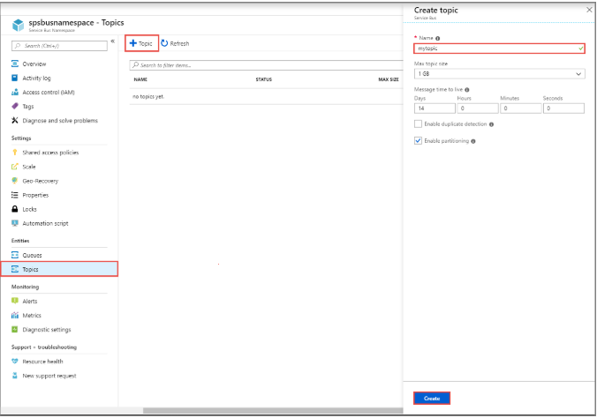

## **Create subscriptions to the topic**

1. Select the **topic** that you created in the previous section.

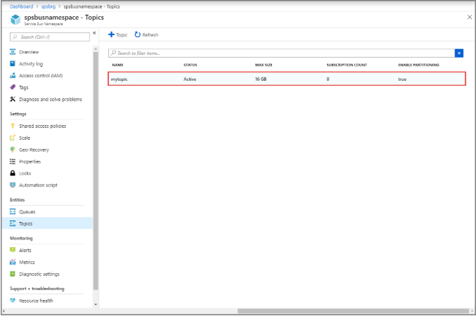

1. On the **Service Bus Topic** page, select **Subscriptions** from the left menu, and then select **+ Subscription** on the toolbar.

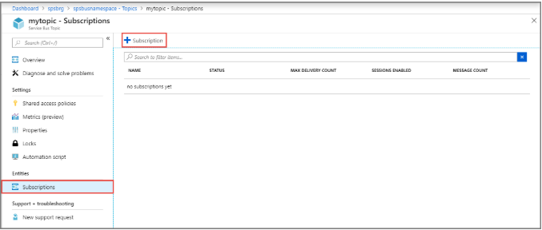

1. On the **Create subscription** page, enter **‘mysubscription’** for **name** for the subscription, and then select **Create**.

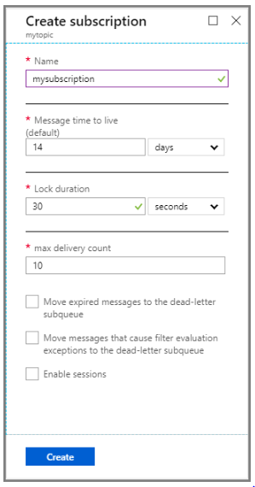

1. Repeat above steps, to create multiple subscriptions to a topic.

#### 